COMPREHENSIVE PLAN

Appendix 8

DRAFT
UTILITIES INVENTORY
AND EXISTING CONDITIONS

August 4, 2017

April 3, 2020

PAGE INTENTIONALLY
LEFT BLANK

APPENDIX 8

DRAFT
UTILITIES INVENTORY
AND EXISTING CONDITIONS

TABLE OF CONTENTS

8.1 INTRODUCTION……………………………………………………………………………………………………………….…………………….1

8.2 ELECTRICITY
8.2.1 Existing Conditions 1
8.2.2 Capacity Needs 3
8.2.3 Community Solar 4
8.2.4 Electric Vehicles and Charging Stations…………………………………………………………………………………….5

8.3 PROPANE…………………………………………………..…………………………………………………………………………………………5

8.4 TELECOMMUNICATIONS
8.4.1 Data & Telephone - Fiber Optic 5
8.4.2 Telephone – Voice over Internet Protocol (VoIP) 5
8.4.3 Wireless – Fixed Wireless Long Term Evolution (LTE) 6
8.4.4 Wireless – Cellular 6
8.4.5 Telephone – Plain Old Telephone Service (POTS) 7

8.5 INTERNET & CABLE SERVICES 7

8.6 COMMUNICATION SITES AND FACILITIES 7

LIST OF TABLES

Table 8.2.1 Capacity of OPALCO Electric Facilities 1
Table 8.2.2 OPALCO Electricity Service Accounts - 2019 3
Table 8.2.3 Public Electric Vehicle Charging Stations 5

LIST OF MAPS
Map 8.2.1 OPALCO Electric Facilities 2

8.1 INTRODUCTION

The Utilities Inventory and Existing Conditions is an appendix to the San Juan County (SJC) 2020 Comprehensive Plan (Plan) Utilities Element. This document provides an inventory of utility services in San Juan County, including electricity, telecommunications, internet and cable, and communication sites and facilities. In San Juan County, private service providers supply utilities to customers. This inventory includes the providers, general locations and capacities of existing utilities where applicable. Planning for utilities aids SJC in ensuring adequate services are provided to different areas of the County, particularly as the County population increases.

8.2 ELECTRICITY

San Juan County relies on electricity generated primarily in the Pacific Northwest and transmitted to the San Juan Islands by the Bonneville Power Administration (BPA) and Puget Power. The BPA was created by Congress in 1937 to act as an agent to market power from Bonneville Dam. BPA has been designated to market power from the 29 additional federal dams located within the Northwest. The BPA does not build or own dams or power plants, but does operate the nation's largest network of long-distance high-voltage transmission lines. The BPA electricity is sold to the Orcas Power and Light Company (OPALCO) at BPA's point of delivery on Lopez Island. OPALCO is the sole electric service provider in San Juan County.

OPALCO is a member-owned, private, non-profit Rural Utility Services (RUS) Cooperative that provides local electric service to its members in San Juan County. OPALCO was formed in 1937 and currently maintains offices in Eastsound, Friday Harbor, and on Lopez Island with headquarters in Eastsound. OPALCO is an electric distribution utility distributing power via submarine cables to members on twenty islands. OPALCO prioritizes energy delivery that is safe, reliable, affordable, clean, and sustainable.

8.2.1 Existing Conditions

According to OPALCO, existing electric utility facilities in San Juan County have adequate capacity to serve existing loads. OPALCO maintains a comprehensive Integrated Resource Plan to expand capacity as load growth occurs. Table 8.1.1 below, lists the location and capacities, in million volt-amps (MVA) of each substation in OPALCO's transmission network.

Table 8.2.1 Capacity of OPALCO Electric Facilities (2019).
Location | Base Capacity (MVA) | Max Capacity (MVA)
Shaw | 5 | 5
Orcas | 12 | 12
Eastsound | 12 | 20
Olga | 7.5 | 7.5
Lopez | 12 | 16
Blakely | 2.5 | 2.5
Decatur | 2.5 | 2.5
Roche Harbor | 12 | 22.4
Friday Harbor | 12 | 22.4
Gravel Pit | 12 | 20
Source: OPALCO 2019

Map 1. OPALCO Electrical Facilities (2019).
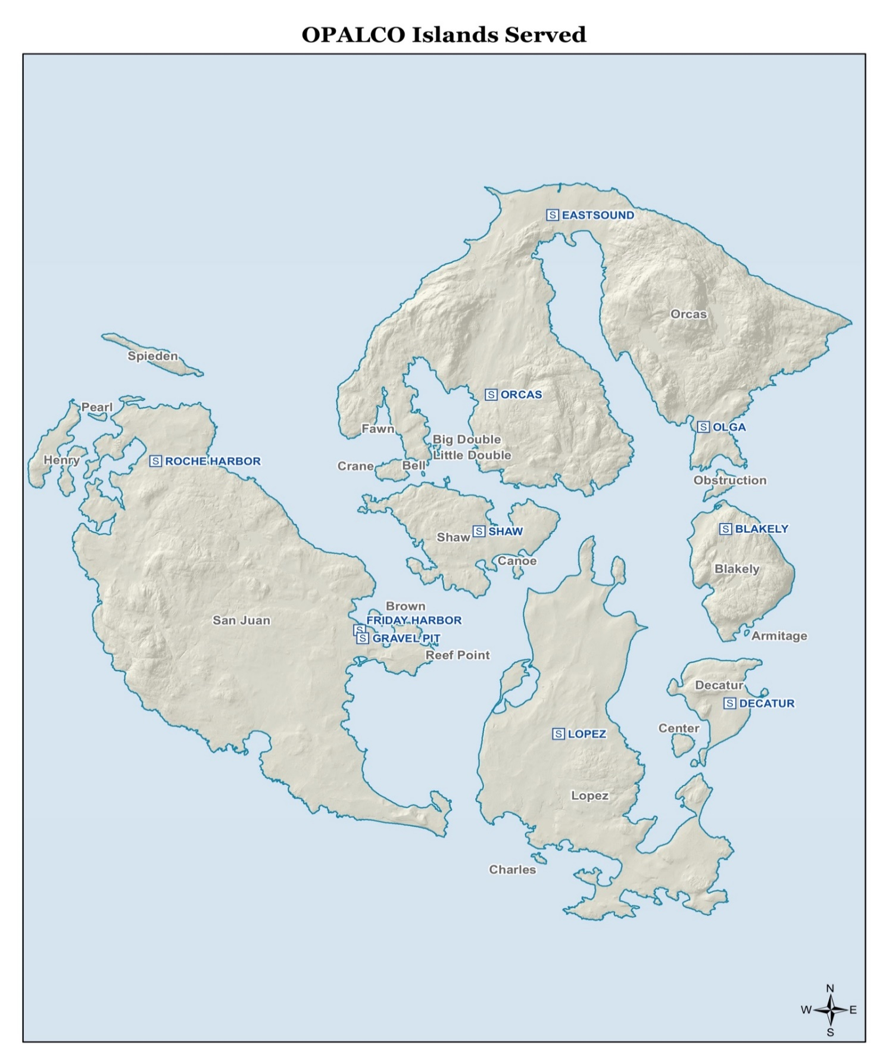

Table 8.2.2 below, lists the number of service accounts by island for 2019.

Table 8.2.2 2019 OPALCO Accounts.
Island | Number of Services
Armitage | 1
Bell | 1
Big Double | 3
Blakely | 166
Brown | 48
Canoe | 6
Center | 142
Charles | 2
Crane | 53
Decatur | 279
Fawn | 1
Henry | 97
Little Double | 1
Lopez | 2,486
Obstruction | 36
Orcas | 4,736
Pearl | 40
Reef Point | 1
San Juan | 6,528
Shaw | 275
Spieden | 11
Total | 14,913
Source: OPALCO 2019

8.2.2 Capacity Needs

An analysis of capacity development necessary to meet future demand is contained in OPALCO's long-range plan. OPALCO also develops load forecasts and construction projects in their 4-year Construction Work Plan (CWP) in addition to its long-range planning program. OPALCO is currently implementing its 2017-2020 CWP which is reviewed and updated annually as necessary. These capital-planning programs are referenced here for future comprehensive planning purposes.

Detailed analyses have been and will be conducted by OPALCO based on planned land use. Planned construction of electric utility facilities serving local load areas is based on existing and projected load rather than time (years). Utilities determine the need for expanded or new electric utility regional transmission network facilities on the basis of established planning standards that define required system performance under specified conditions including load and generation levels, equipment outages, weather, and equipment ratings. As the electric load within San Juan County grows due to an increase in customers and demand, OPALCO will need to add new electrical facilities to increase the capacity of its distribution system. OPALCO estimates an average annual increase of 0.5 percent for residential accounts and 2.0 percent for commercial accounts. Since 2007, OPALCO has increased its consumer accounts by approximately 10 percent or an increase of over 1,400 customers.
8.2.3 Community Solar

OPALCO operates a 500 KW solar array located on 3.6 acres at the Decatur Substation. This is OPALCO’s first Community Solar Project—a program where members offset a portion of their energy use and electric bill via credits by buying shares of a solar array OPALCO operates. Decatur Community Solar began operating in July 2018, and is expected to produce approximately 570,000 kWh/year. More solar projects may be a part of OPALCO’s effort to become more energy independent from mainland energy sources.

San Juan Islands Conservation District and OPALCO promote solar energy projects in the county in partnership with the Bonneville Environmental Foundation and local solar installers. The Community Solar for Our Schools program provided solar array installations to generate power for public schools on Orcas, San Juan, Lopez and Shaw islands.

8.2.4 Electric Vehicles and Charging Stations

San Juan County has two EVs and two EV charging stations. One EV is on San Juan Island where the County had a charging station in the parking garage beneath the Legislative Building. There is also an EV on Orcas where there is a charging station at the Orcas Ferry Landing. The County is considering purchasing another EV and installing another charging station, to be located on Lopez Island. County EV charging stations are not for public use.

According to the San Juan Islands Conservation District (SJICD), San Juan County has the highest number of public EV chargers per capita in Washington State. There are EV charging stations available to the public on San Juan, Orcas, and Lopez islands, shown in table 8.2.3 below. The SJICD provides some funding for businesses and organizations to install public EV chargers.

Table 8.2.3 Public Electric Vehicle Charging Stations
Location Name | Address | Number of Stations
SAN JUAN ISLAND
Port of Friday Harbor | 200 298 Front St N | 1
Key Bank | 95 2nd St | 3
Earthbox Motel and Spa | 410 Spring St. | 2
Friday Harbor Grand Bed and Breakfast | 345 Blair Ave | 1
Avalon Business Park | 322 Daniel Ln | 1
Sweet Earth Farm Store | 5658 West Side Rd | 1
Snug Harbor Resort | 1997 17 Mitchell Bay Rd | 1
ORCAS ISLAND
Orcas Island Ferry Terminal | 156 Orcas Rd | 1
Odd Fellows Hall | 112 Haven Rd | 1
Orcas Island Market | 469 Market St | 2
Rosario Resort | 410 Ocean Mist Way | 2
Doe Bay Resort | 107 Doe Bay Rd | 1
LOPEZ ISLAND
Lopez Community Land Trust | 25 Tuatara Rd | 1
Lopez Village Market | 162 Weeks Rd | 3
Ark Veterinary Clinic | 262 Weeks Rd | 1
Lopez Island Library | 2225 Fisherman Bay Rd | 1
Southend General Store and Restaurant | 3024 Mud Bay Rd | 1

8.3 PROPANE AND NATURAL GAS

Propane is an important energy source in San Juan County. Natural gas is not available in the County, contributing to the reliance on propane. Propane in San Juan County is provided by private suppliers, including Inter-Island Propane and San Juan Propane. Inter-Island Propane is located in Friday Harbor and on Lopez Island. They currently provide barge service to Orcas, Shaw, and to the outer islands by request. Inter-Island propane has been permitted to build and operate a new facility in Eastsound. San Juan Propane is located in Friday Harbor, Eastsound, and Island Center on Lopez Island. San Juan County’s involvement with propane extends only to land use issues. Safe delivery of propane from ports is a priority.

8.4 TELECOMMUNICATIONS (DATA & VOICE)

8.4.1 Data & Telephone - Fiber Optic

The availability of fiber optic based services has grown extensively throughout the county in the past decade. This is meeting the growing needs of the electric grid, emergency communications, residential and business broadband and cell phone service. In Mid-2015, deployment of Fiber to the Home and Premise (FTTH & FTTP) began throughout the county. As of October 2019, approximately 50 percent of the County (7,500 addresses) is located within a serviceable distance (500 feet or less) of existing fiber optic facilities. Of those addresses, 1,800 are utilizing fiber optic service. As demand for higher bandwidth and additional improvements are made to public infrastructure, the availability of fiber optic services will continue to grow. The FTTP system enables homes and businesses to scale their needs up to 1Gbps (1,000 Mbps) upon initial installation with the ability to go to 10Gbps (10,000 Mbps) as required. Fiber is considered a future-proof technology that allows for massive increases in available bandwidth for generations to come. The average monthly new connection rate is 30-40 locations. The fiber is spanning 500 plus miles connecting all major islands and to the mainland with multiple upstream connections in Bellingham and Seattle.

8.4.2 Telephone – Voice over Internet Protocol (VoIP)

With the increase use of data communication services, Voice over Internet Protocol (VoIP) has become the predominate method for non-wireless based voice communications around the nation, particularly for businesses. VoIP services are dependent on reliable, low-latency internet connectivity. Unlike Plain Old Telephone Service (POTS) lines, the Washington Utilities and Transportation Commission (WUTC) does not regulate VoIP.

There are various resellers of VoIP services for residents and businesses in San Jun County. Anyone with a reliable internet connection can purchase voice services from a variety of national providers. Each of these providers deliver a wide variety of services and advanced features based upon the consumer requirements.

8.4.3 Wireless – Fixed Wireless Long Term Evolution (LTE)

In addition to deploying Fiber To The Home (FTTH) around the County, Fixed Wireless LTE has been deployed. LTE has been deployed to service areas where fiber is unavailable currently. LTE is a standard for wireless broadband communication for mobile devices and data terminals. It increases the capacity and speed using a different radio interface together with core network improvements. Fixed Wireless LTE utilizes cellular technology enabling high-speed data and voice connections in the range of 25Mbps to 150 Mbps. As of October 2019, 3,000 locations are served with fixed wireless broadband service. This service is recognized nationally as one of the top 10 fastest wireless services available to U.S. residents and the highest available offering in Washington State. Service is provided to 18 non ferry-served islands, some without utility power service. With increased capacity being added regularly, this service is available to over 4,500 locations in San Juan County.

8.4.4 Wireless – Cellular

Personal wireless communication facilities are not classified as public utilities or essential services, but are a commercial service. Nationally, the Federal Communications Commission (FCC) regulates the airwaves and the personal wireless communications industry and is responsible for issuing construction permits for transmission facilities and licenses to operate wireless systems. All major national cell phone providers have a presence in San Juan County from T-Mobile, Verizon, AT&T and Sprint to smaller service providers. Overall capacity of the network with multiple new frequency bands opening enables for higher throughput and data rates. It is expected providers will expand their capacity and coverage area over time to accommodate their respective customer base.

Local governments regulate the development of the wireless communications network by specifying where facilities can locate, applying buffering and setback requirements, etc. Federal case law from regulating facilities covered by the Federal Aviation Administration (FAA) has preempted local governments. The FAA reviews the location and height of proposed support structures to prevent interference with operations of airports and flight paths. The FAA regulates proposed towers that exceed 200 feet and smaller structures located within 20,000 feet of a major airport and 10,000 feet of a general aviation airport. The FAA does not have the authority to deny an FCC construction permit, but it can cite a proposed support structure as a hazard to navigation. (See the discussion on Airport facilities in Element II-D Transportation.) In 2014, San Juan County adopted a joint use wireless ordinance enabling the broader development of wireless infrastructure for essential public services.

8.4.5 Telephone - Plain Old Telephone Service (POTS)

CenturyLink, based in Monroe, Louisiana, is the primary provider of POTS (Plain Old Telephone Service), to approximately 10,000 residential and business customers in the county. The number of locations decreases as consumers discontinue landline service or port their number over to VoIP providers, such as Rock Island Communications, a subsidiary of OPALCO. In addition, CenturyLink also provides digital subscriber line (DSL) service; as well as private dedicated services (i.e. Ethernet) which helps meet the needs of telecommunication customers throughout the county.

CenturyLink provides service to the county via a fiber optic cable network that connects all the major islands to the mainland. It provides these essential services to meet the needs of telecommuters and those who run businesses from their homes. Service is currently provided to Blakely, Brown, Center, Crane, Decatur, Henry, Lopez, Obstruction, Orcas, Pearl, San Juan and Shaw Islands.

Geographic isolation and comparatively small resident populations have historically inhibited the extension of telephone service to some islands within the county, such as Stuart Island.

8.5 INTERNET & CABLE SERVICES

Fast, reliable Internet connection is increasingly important to economic development, health and safety, and daily life in San Juan County. Broadband Internet connection allows residents opportunities to work remotely and connect with others globally. Medical facilities and emergency services rely heavily on broadband Internet in order to provide modern, up-to-date care. The Economic Development Element of this Comprehensive Plan states the goal of “support[ing] development of reliable high-speed (100 Mbps or higher, or the current standard for urban regions of the U.S., whichever is higher) broadband infrastructure that enables the creation of jobs and improved educational opportunities for islanders, and increased competitiveness for the county.” Internet utility infrastructure comes in several forms, including LTE fixed wireless, fiber, and cable.

Rock Island Communications provides broadband Internet via LTE fixed wireless and fiber in San Juan County. Rock Island is a subsidiary of OPALCO, as of 2015. Fiber connectivity is growing rapidly, with LTE providing service in areas awaiting fiber deployment. Cable Television and Internet services have continued to see a significant decrease throughout the county with CenturyLink, Zito Media and PogoZone covering parts of Friday Harbor and Orcas Island. This decline has been driven by the consumer move to online streaming services such as Netflix, Hulu and Amazon as broadband services via fiber and wireless increase, in addition to increased competition from satellite providers.

8.6 COMMUNICATION SITES AND FACILITIES

Antennae and towers atop Mt. Constitution on Orcas Island are used to provide broadcast communications and electronic controls. As telecommunications technology and demands continue to change, service providers must retain the ability to expand existing and build new antennae and towers for operational purposes.

Mt. Constitution Sites, Inc. owns 160 acres of land within Moran State Park and leases communication towers to approximately 40 users. In all they have five towers with three primary sites ranging from 500’, 400’, to a 235’ tower, located in the northeast corner of this property.

East of the 160-acres of private property mentioned above, the U.S. Coast Guard leases a one-acre site from the Washington State Parks and Recreation Commission (WSPRC) and operates a 100-foot tower with microwave dishes to monitor small vessels. KVOS leases a one-acre site from the WSPRC at the 2,409 summit of Mt. Constitution and operates a transmitter facility and a 150-foot tower. Washington State Department of Transportation (WSDOT) leases a one-acre site from WSPRC southwest of the KVOS site and operates two 70-foot towers. The U.S. Forest Service also leases one acre from WSPRC and operates two 70-foot towers. The University of Washington also operates a seismographic telemetry station at this site. This site may, at some point, no longer be sufficient for future forms of, or demand for, personal wireless services. The county adopted Ordinance 8-1997, which established a subarea plan and requirements for future personal wireless communication service facilities through Chapter 16.80 of the SJCC.

