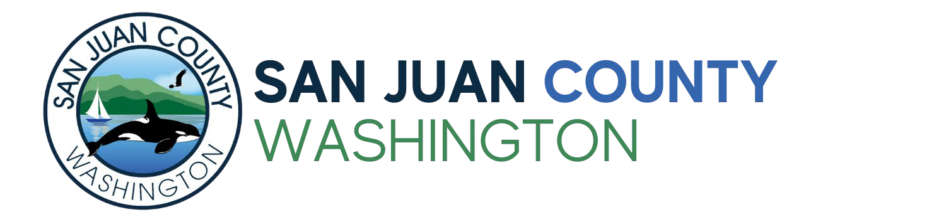

PUBLIC FACILITIES FINANCING ASSISTANCE PROGRAM (PFFAP)
2025 APPLICATION AND PROJECT PROPOSAL
Expenditures of Rural Sales and Use Tax received by San Juan County must meet all the following requirements:
- The funds must be used for “public facilities” as defined in RCW 82.14.370;
- Funded projects must be listed as an item on the County Economic Development Plan, or in the economic development section of the county’s comprehensive plan, or the comprehensive plan of a city or town located within the county or provide affordable workforce housing infrastructure or facilities; and
- Each public facility must foster economic development in the community.
- Projects must fall under one of the eligible public facility types listed in Appendix A of Resolution 17-2018 (attached)
- Projects must be designed to increase capacity and not address a deficiency unless that deficiency is a direct impediment to economic development.
Projects must also address one or more goals as mentioned in Element 10 of the San Juan County Comprehensive Plan. See attached before filling out this application.
Applications will be reviewed by the Prosecuting Attorney for eligibility.

Applications are due by 5:00 pm Monday, June 2nd, 2025. Email completed applications to Aiden Haines at aidenh@sanjuancountywa.gov
Please fill out the following application completely. Attach a complete project budget, copies of any bids already obtained, and additional relevant documents to this application form.
Organization: Federal ID #: Mailing address: Contact person: Title: Email: Phone: Organization website address (if applicable):
Project Title (brief name):
Total project cost: $ Total amount requested: $ Is this request for multiple-year funding? Yes No
If Yes, number of years: Amount per year: Other agencies involved: Funding obtained from other agencies: Required matching funds, and by whom required: Estimated start date: Estimated completion date: Contingencies to be satisfied before project can proceed:
Signature of Authorized Representative (required): Date:

San Juan County Public Facilities Financial Assistance Program Application Page 2

Please answer the following questions with respect to your application:

- How does your proposal foster economic development within San Juan County?

- Is the proposal designed to increase capacity or address a deficiency? If the proposal is designed to address a deficiency, describe whether the deficiency is a direct impediment to economic development and why.

- A key goal of these funds is to foster the creation of living wage jobs directly or indirectly through development of enabling facilities.
  - Provide a forecast for 5 years after project completion on the jobs (full time equivalents) created, or job losses averted, by your project.
Yr 1 Yr 2 Yr3 Yr4 Yr5
  - Describe the type and magnitude of economic value created that will be providing ongoing funding for these positions (e.g. incremental income to proposing public entity, enabled businesses starting or expanding).
  - What is the efficiency of this project in using San Juan County financial resources in creating the above value? Divide your estimate the total wages generated (or saved) in the first 5 years after project completion by the total county-sourced funds for the project.
- Will this project require continuing funding support or will revenues from the completed project fully support future operations and maintenance?

- Describe any additional qualitative benefits from the infrastructure created by this project that are aligned with the goals of the Comprehensive plan.
- What is the confidence with which these benefits can be projected? What execution issues or external factors could materially impact the forecast?
- Please address these questions for the committee to assess your readiness to execute your project with any funding granted

  - What is the status of the engineering reports, feasibility studies and permits required to execute the project? Describe steps remaining to secure any remaining permits.
  - List the status of all significant funding dependencies for this project to be completed. Identify source, amount of funds sought, and whether they are currently applied for or committed.
If there are conditions attached to any of these funding sources please specify.

  - When is project slated to be started and completed?
  - Is this project part of a larger public facility plan? If yes, please explain.

- Which element(s) of the Comprehensive Plan does this project constructively address?
- Are there other factors significant to this project that we should be aware of?

- What quantifiable outcomes will you track to measure the success of this project?

ResolutionNo. I; -2018 Page 3 of 3

APPENDIX A - San Juan County Economic Development Plan

List of eligible project types for the Public Facilities Financing Assistance Program (PFFAP)*:

Agriculture/ Aquaculture/Timber
Product processing facilities, such as: commercial kitchens, seed production facilities, timber mills Product sales, marketing and distribution facilities, such as: Food hubs, farmers' markets

Alternative Energy
Energy production, storage and distribution facilities

Economic Development Projects
Shared workspaces, business incubators, trades & business training facilities, business parks Personnel in economic development (ADO) offices

Health Care
Public hospitals and/or Long-term care facilities

Maritime Industries
Marine research facilities Boat building, repair facilities
Marine industry incubators and/or Training facilities

Telecommunications
Broadband/communication infrastructure, such as: Cell/communication towers, fiber optic installations, joint use wireless facilities

Tourism
Park and/or event facilities, such as: Public pools, public restrooms and signage Public access to shorelines and/or trails

Transportation
Roads including intersection improvements
Public transportation improvements, such as: Bridges, non-motorized pathways, public parking, boardwalks
Public marina improvements, such as: Barge landings, boat launches, docks
Public airport improvements, such as: Buildings, emergency medical transportation infrastructure Ferry landing and parking improvements

Utilities
Water, wastewater and stormwater systems Solid waste, recycling and composting facilities
* For projects to be eligible for funding, they must be designed to increase capacity and not address a deficiency, unless that deficiency is a direct impediment to economic development.

San Juan County Comprehensive Plan

10.1.B Overarching Goals
To maintain its share of natural capital and develop its human assets while achieving and enhancing a balanced county economy, four interrelated goals for the EDE of the Plan have been identified. These are expanded upon in section 10.3.B.
- Goal 1: CREATE LIVING WAGE JOBS: Establish and maintain a sound, stable, year- round, and locally based diversified economy that creates living wage jobs in community and environmentally friendly industries consistent with rural character.
- Goal 2: DEVELOP A BROADLY COMPETENT WORK FORCE: Train a resident work force to support and attract diverse businesses (in harmony with the county’s natural resources), perform work otherwise done by labor and skills sourced from outside the county, and supplement an aging talent pool.

Goal 3: IMPROVE INFRASTRUCTURE AND COMMUNITY ASSETS AND SERVICES:
Support and maintain infrastructure, community assets, and environmental resources; enhance economic, environmental, and community resilience; and protect environmental services and natural assets in a manner consistent with rural character.
- Goal 4: ENHANCE ECONOMIC RESILIENCE: Enhance economic resilience to rapid and long-term natural and economic disruptions.

10.2 Authority, Purpose and Other Elements
10.2.A Authority
This EDE is adopted pursuant to RCW 36.70A.070 (7) of the Washington Growth Management Act (GMA) which mandates that the County’s Comprehensive Plan include:
“[a]n economic development element establishing local goals, policies, objectives, and provisions for economic growth and vitality and a high quality of life.”
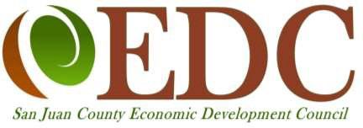
This is subject to an overarching instruction preceding this mandate relating specifically to the economic element: “Encourage economic development throughout the state that is consistent with adopted comprehensive plans, promote economic opportunity for all citizens of this state, especially for unemployed and for
disadvantaged persons, and encourage growth in areas experiencing insufficient economic growth, all within the

Section B, Element 10. Economic Development Page 3 of 12 November 2022

