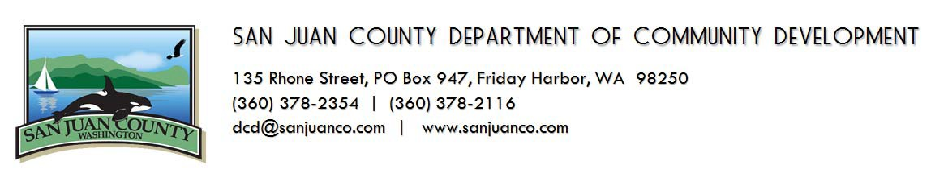
REQUEST FOR CODE ENFORCEMENT
It is the policy of the Department of Community Development (DCD) not to accept anonymous complaints of alleged violations of San Juan County code (SJCC). (To request a written copy of this policy, please contact DCD.) To assist the Department of Community Development in its code enforcement efforts, please fill out this form. Be as specific and detailed as possible. When completed, return to the address above, attention Code Enforcement.
Reporting Party:
Name:
Mailing Address:
Phone:
e-mail:

Location of code violation(s) (address/TPN):
Island:
Person/Party believed to be in violation (if known):
Property/Business Owner’s Name:
Address:
Phone:

Description of violation (attach separate pages if necessary):

Section(s) of San Juan County Code believed to be violated (if known):

Signature of Complainant
Date

